Biography
November 9 2023
Hak K. Pyo
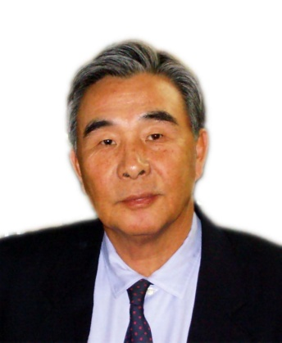
Hak K. Pyo is Professor Emeritus, the Faculty of Economics, Seoul National University. He has served as Professor of International Economics and Econometrics at Seoul National University since 1981 until February 2013. He was born in Milyang, Korea on February 16, 1948. He earned BA from Seoul National University (1970) and Ph. D from Clark University (1977). He also served as Visiting Professor at International Monetary Fund (1989-1990), Paul Nitze School of Advanced International Studies, Johns Hopkins University (1997-1998), and the Faculty of Economics, University of Tokyo (1998-1999; 2005 June-August). He has lectured, Korean Economy, as Visiting Professor at UCSD, School of International Relations and Pacific Studies during Winter Quarter in 2006-2011. He was Visiting Scholar at Korea Institute of Finance in 2013-14 and Korea Institute for International Economic Policy in 2014-2016.

Professor Pyo was the winner of Chung Ram Award in 1988 by Korea Economic Association for his study on the estimation of capital stock. He served as President of Korea Econometric Society in 1997, Director of Institute for World Economy, Seoul National University in 1996, and President of Korea International Economic Association in 2009. He also served as Member of Presidential Commission for Policy Planning during 1993-1996. He was Director of Center for National Competitiveness (CNC), Seoul National University during 2002-2013. He also served as Chairman of Asia KLEMS Committee (www.asiaklems.net) during 2009-2013 and now serves as Advisor to the Committee.

He served as consultant to Asian Development Bank (1996), World Bank (1997), and Institute of Developing Economies in Tokyo (1992-1998). He published many articles in professional journals and books including “Inflationary Expectations, ‘Endogenous Money’, and Economic Growth”, Journal of Macroeconomics (1986), “The Transition in the Political Economy of South Korean Development”, Journal of Northeast Asian Studies (1993), “Excess Competition, Moral Hazard and Industrial Trauma in Korea, 1977-1998”, in Private Capital Flows in the Age of Globalization: The Aftermath of the Asian Crisis, edited by U. Dadush, D.Dasgupta, and M. Uzan, Edward Elgar, Northampton, MA, 2000, and “Financial Crisis and Relative Productivity Dynamics in Korea: Evidence from Firm-level Data (1992-2003)” (with Keun Hee Rhee), Journal of Productivity Analysis (2010) and Chapter 23 Productivity and Economic Development in Oxford Handbook of Productivity Analysis edited by Lovell, Sickles and Tatje, Oxford University Press, 2017 (forthcoming).
Ho Chi Minh University-Hanoi University
Special Lecture November 16 (Ho Chi Minh) and 17 (Hanoi) 2023

Trade and Development with Human Capital in Korea (1910-2022):
A Century’s Narrative

Hak K. Pyo
hakkpyo@gmail.com
Professor of Economics Emeritus
The Faculty of Economics
and
Visiting Scholar, Asia Center
Seoul National University

Summary

The lecture discusses the Five Stages of Economic Development in Korea:((1) The Port-opening and the Japanese Colonial Rule (1910-1945) (2) The Development in the Rhee Regime (1945-1961) (3) The Development under the Park Regime (1962-1980) (4) The Development in transition to Democracy (1981-1991) (5) The Development under the Civilian Rule (1992-2022). The lecture reviews a more recent development policy which attempts the Third Way, a mixture of capitalism and socialism. The lecture highlights the consequence of implementing the Third Way which is the total failure of mixing capitalism with socialism. The lecture concludes with finding ways for the Fourth Way restoring growth momentum of the Korean Economy. The last section discusses the pattern of productivity convergence in Korea and Vietnam with OECD Member Countries. The value-added growth accounting results of Korea and Vietnam from APO database is examined. The lecture concludes with implications for development in Vietnam by emphasizing the importance of maintaining open trade and investment regime which will promote the build-up of human capital which is the ultimate source of sustainable economic growth.

