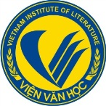 |  | 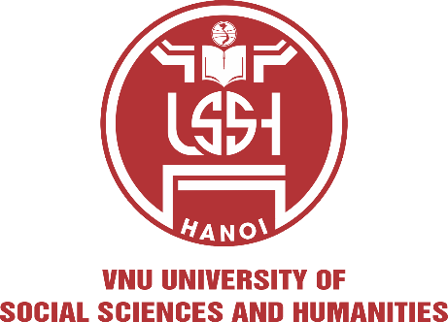
CALL FOR PROPOSALS

The 2026 International Conference of ASEAN Studies

To be held at Hanoi, Vietnam on 22~24 October 2026
Co-organized by Korea Institute for ASEAN Studies, Busan University of Foreign Studies (KIAS-BUFS), University of Social Sciences and Humanities, Vietnam
National University, Hanoi (USSH-VNU), and Institute of Literature - Vietnamese Academy of Social Sciences (VIL-VASS)
Venue: University of Social Sciences and Humanities, VNU (336 Nguyen Trai, Thanh Xuan, Hanoi, Vietnam)

Conference Themes:
ASEAN-ROK Partnership in the Era of Crisis:
Bridging Development, Innovation, and Cultural identity

In an era of climate emergencies, pandemic threats, economic disruptions, and rising geopolitical tensions, the partnership between ASEAN and the Republic of Korea stands at a critical turning point. Both regions face the challenge of building resilient pathways that bridge sustainable development, technological innovation, and cultural preservation.
This conference examines the many dimensions of ASEAN-ROK relations, addressing shared challenges including climate change, digital divides, inequality, and geopolitical tensions while exploring collaborative solutions through strategic partnerships, mini-lateral cooperation, and people-to-people connectivity to build a more equitable, sustainable, and crisis-resilient regional order.
Against this backdrop, the Korea Institute for ASEAN Studies, Busan University of Foreign Studies (KIAS-BUFS), the Faculty of Oriental Studies at University of Social Sciences and Humanities, Vietnam National University, Hanoi (USSH – VNU Hanoi), and the Vietnamese Academy of Social Sciences (VASS) are collaborating as leading scientific institutions to organize this international conference. The conference brings together scholars, policymakers, and practitioners to analyze how ASEAN and ROK can jointly advance the interests of the Global South while maintaining regional centrality and strategic autonomy.
The conference invites lecturers and researchers at the University of Social Sciences and Humanities, Vietnam National University, Hanoi continue to submit panel proposals on any topics related to the conference themes. Papers on the following sub-themes are particularly welcomed:

- ASEAN-ROK Strategic Partnership in the Global South Context
- Mini-lateral Cooperation between ASEAN Sub-Regions and Korea
- Emerging Issues in ASEAN-ROK Relations
4. General Topics:
- Climate Justice and Green Transition
- Inclusive Development and Social Equity
- Cultural Diplomacy and People-to-People Connectivity
- Geopolitics, Security, and Regional Order
- Higher Education and Knowledge Networks
- Digital humanities
- Economy and Literature & Art
- Cultural Industry
- Literatures and Cultures of Ethnic Groups
- Southeast Asian Cultures in Korea

Submission of Proposals/Paper Summaries, and Journal Publication
1. We kindly request that only Panel proposals be submitted, as individual paper submissions are not being accepted.
2. Panel proposals must include the session title along with the titles and abstracts of all proposed papers.
3. The paper summary should be written in English, spanning 5 pages of length, and should clearly present the core arguments of the paper.
4. Following the conference, authors are expected to finalize their presented papers for submission to SUVANNABHUMI: Multidisciplinary Journal of Southeast Asian Studies (SCOPUS) or other academic journals published by the co-host entities. Please note that not all papers will be published. All submissions will undergo a rigorous peer-review process prior to publication.
5. Schedule for proposal and paper summary submission:
Submission of panel proposals and curriculum vitals: 13 March 2026
Confirmation of acceptance: 14 March 2026
Submission of paper summaries (for selected proposals only): June 20, 2026 Submissions should be made via email to seacomplit@gmail.com

Conference Schedule
Participants arrival and hotel check-in: 22 October 2026
Conference day: 23 October 2026
City tour and farewell lunch: 24 October 2026

Organization of the Conference
- All participating institutions and organizations shall be listed as the Co-host entities.
- Co- host entities may invite their panelists from their academic networks.
- Co-host institutions are responsible for arranging airfare and hotel accommodations for their invited participants.
- The co-organizers, KIAS-BUFS, USSH-VNU and VIL-VASS, will provide conference venue and kits, meals, and a city tour for all participants.
- The Co-host entities shall prepare and promote its institutional or organizational identity and its academic journal publication at the conference venue.

Contact to:
Conference Organizing Committee
Korea Institute for ASEAN Studies (KIAS-BUFS)
University of Social Sciences and Humanities, Vietnam National University, Hanoi (USSH-VNU)
Institute of Literature - Vietnamese Academy of Social Sciences (VIL-VASS)
Office: +82-51-509-6644
Email: kiasbufsconf@gmail.com

